Byron Laferriere
Professor Gupta
DAD-220
24 May 2020

DAD 220 Module Three Major Activity Database Documentation Template

Step One: Create a Database

- In your integrated development environment (IDE), create a database schema called QuantigrationRMA. List out the database name. Provide the SQL commands you ran to successfully complete this in your answer, then connect to it:
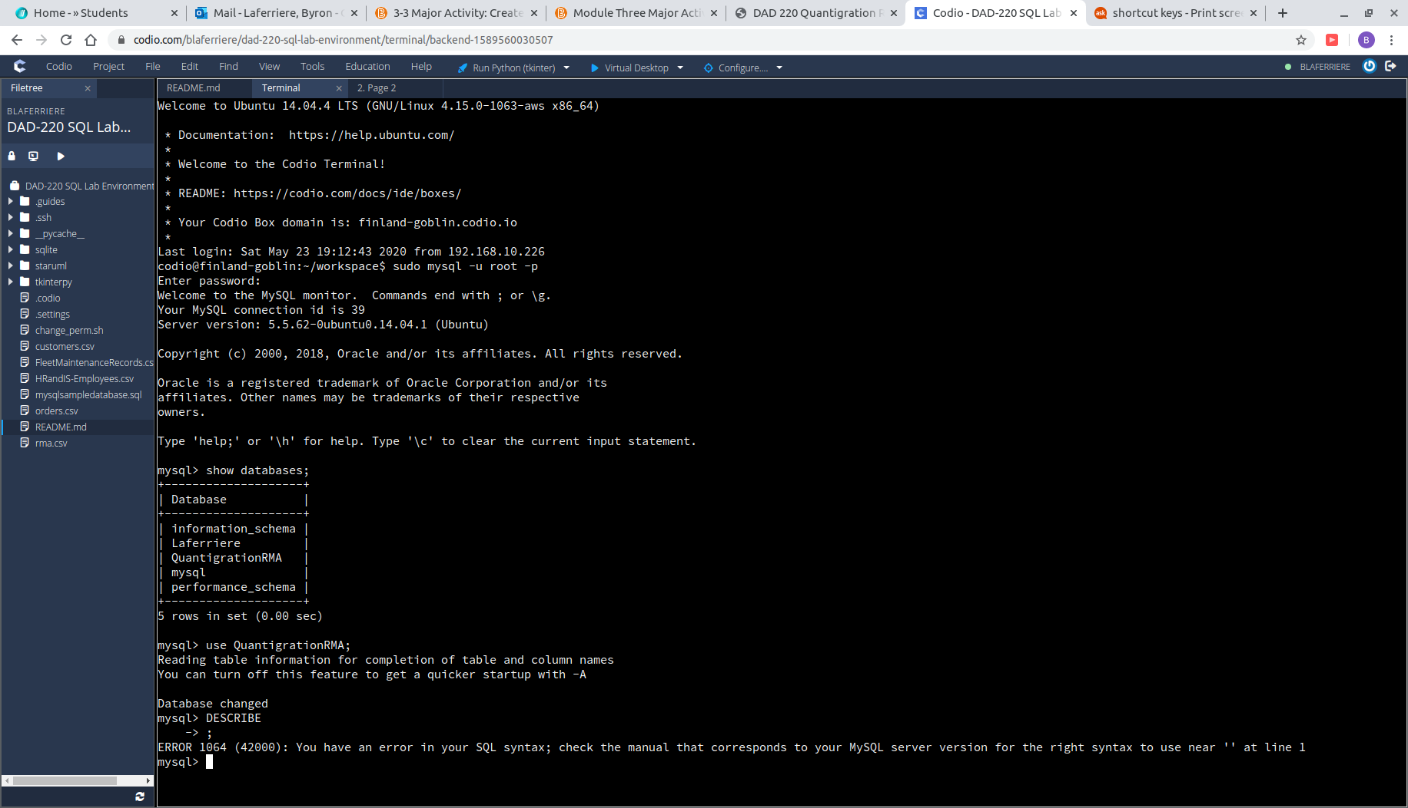

- To first enter MySQL I used the command:
sudo mysql -u root -p
- To CREATE database QuantigrationRMA and connect to it I will use the command:
CREATE database QuantigrationRMA;
show databases;
use QuantigrationRMA;

- Using the ERD as a reference, create the following tables with the appropriate attributes and keys:
  - A table named customers in the QuantigrationRMA database as defined on the project ERD. Provide the SQL commands you ran against MySQL to complete this successfully in your answer:

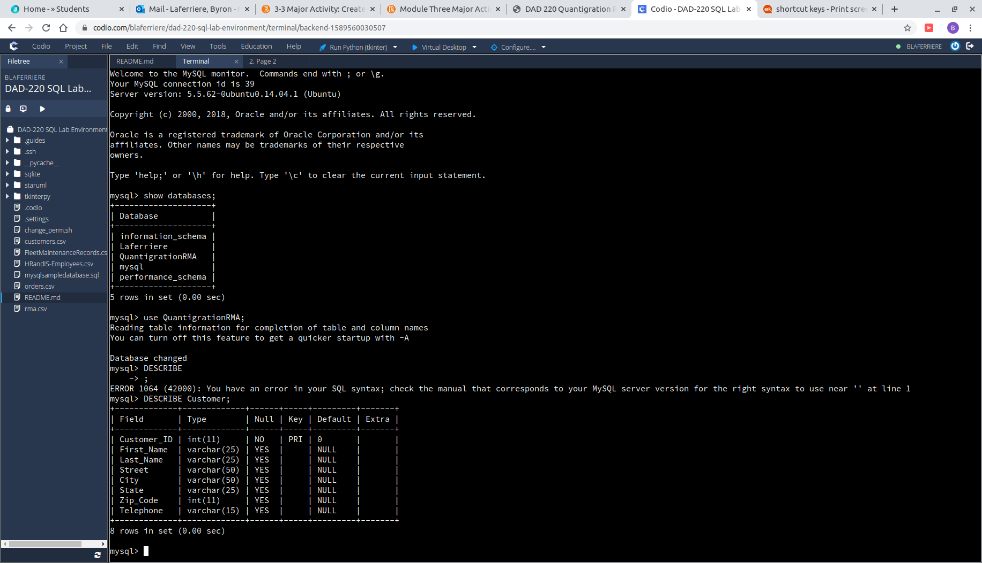

  - To create the table and columns for the Customer table, the following command was used:

CREATE table Customer (
→ Customer_ID INT,
→ First_Name VARCHAR(25),
→ Last_Name VARCHAR(25),
→ Street VARCHAR(50),
→ City VARCHAR(50),
→ State VARCHAR(25),
→ Zip_Code INT,
→ Telephone VARCHAR(15),
→ CONSTRAINT Customer_pk PRIMARY KEY (Customer_ID) );

- I assigned the constraint of primary key to Customer_ID as requested. When writing the command I created the symbol ‘customer_pk’ to hold the place of the primary key.

  - A table named orders in the QuantigrationRMA database as defined on the project ERD. Provide the SQL commands you ran against MySQL to complete this successfully in your answer:
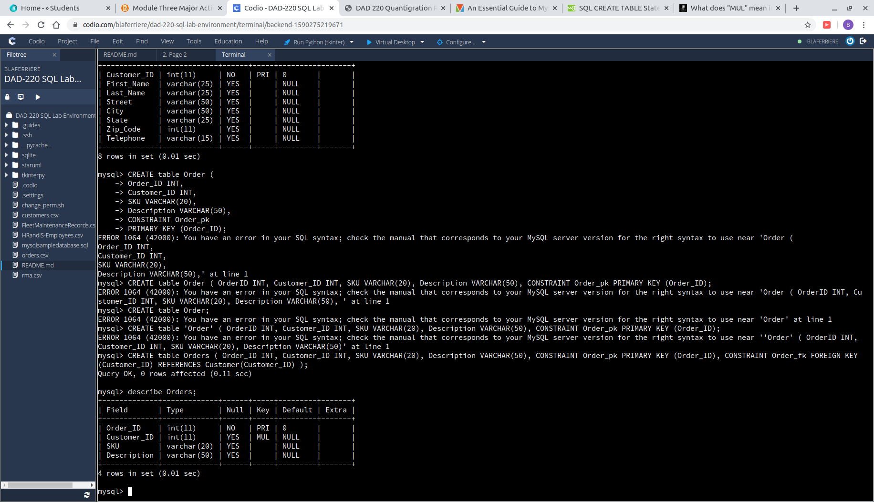

- To create the table and column for the Orders table, the following command was used:

CREATE table Orders (
→ Order_ID INT,
→ Customer_ID INT,
→ SKU VARCHAR(20),
→ Description VARCHAR(50),
→ CONSTRAINT Order_pk PRIMARY KEY (Order_ID),
→ CONSTRAINT Order_fk FOREIGN KEY
(Customer_ID) REFERENCES Customer(Customer_ID) );

- The table Orders, according to the ERD, has a primary key and a foreign key that need to be assigned. Following the same format from step a, I created a symbol called ‘Order_pk’ and assigned the primary key to Order_ID. To assign our foreign key, I linked our Customer_ID from this table to the Customer_ID in the table Customer.

  - A table named rma in the QuantigrationRMA database as defined on the project ERD. Provide the SQL commands you ran against MySQL to complete this successfully in your answer:
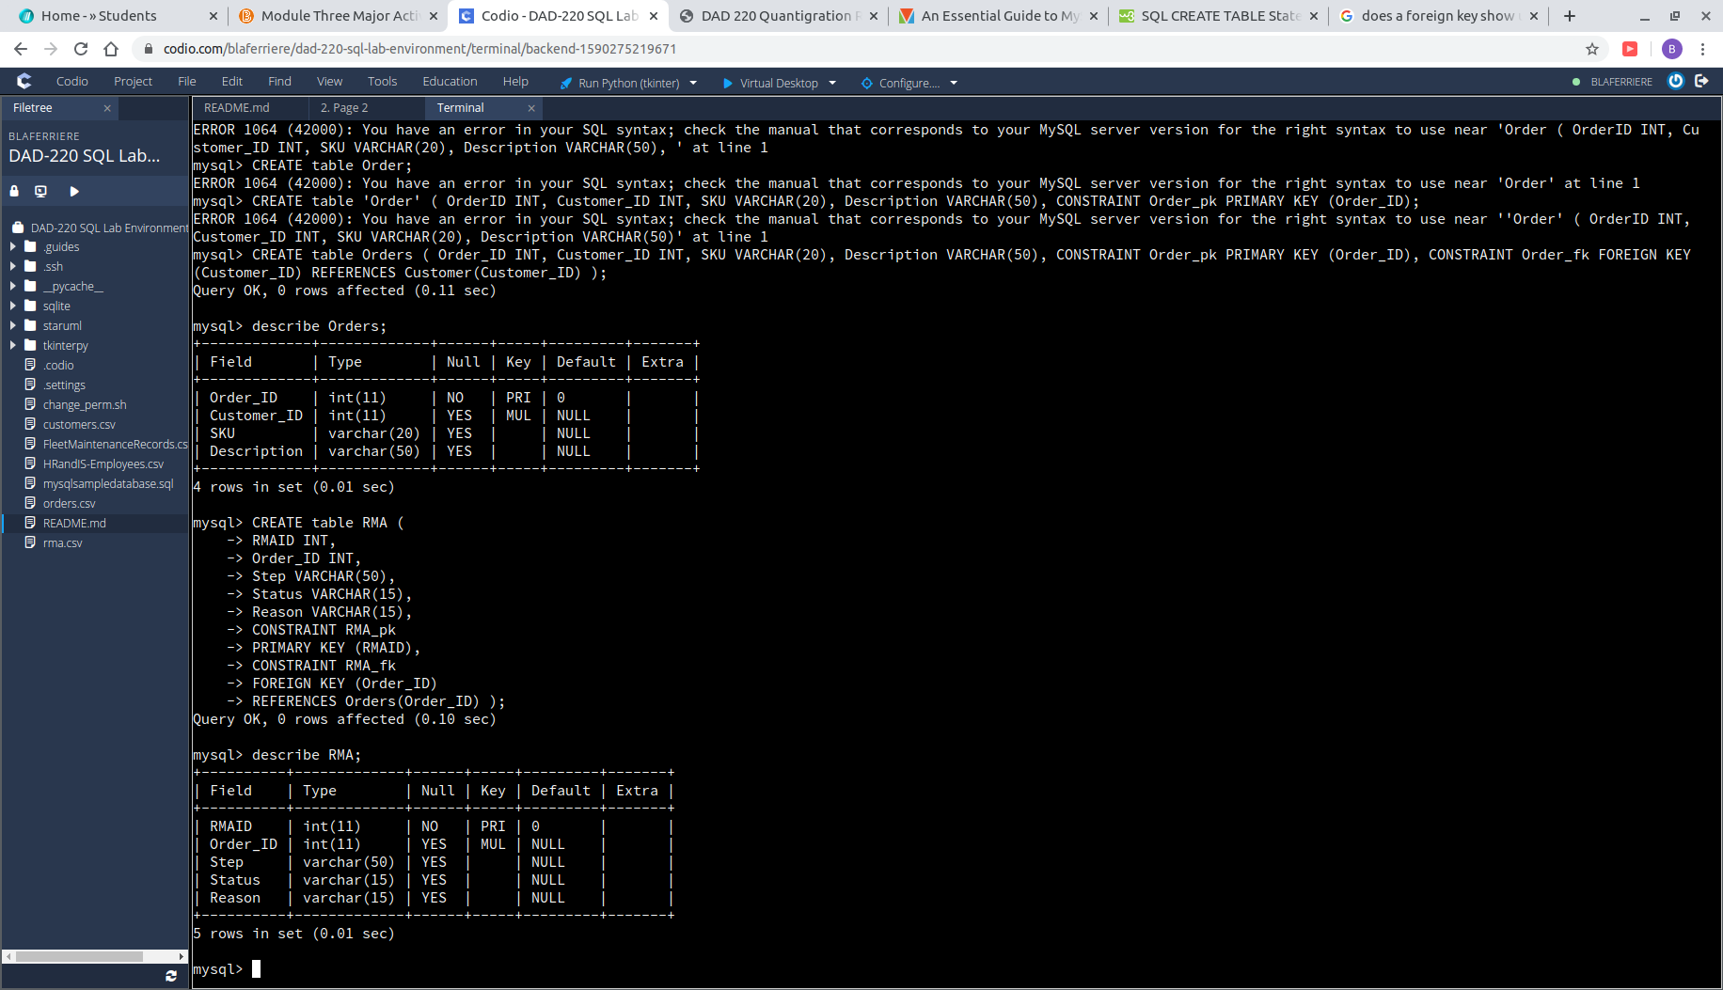

- To create the table and columns for the RMA table, the following command was used:
CREATE table RMA (
→ RMAID INT,
→ Order_ID INT,
→ Step VARCHAR(50),
→ Status VARCHAR(15),
→ Reason VARCHAR(15),
→ CONSTRAINT RMA_pk
→ PRIMARY KEY (RMAID),
→ CONSTRAINT RMA_fk
→ FOREIGN KEY (Order_ID)
→ REFERENCES Orders(Order_ID) );

- The table RMA, according to the ERD, has a primary key and a foreign key that need to be assigned. Following the same format from step a and b, I created a symbol called ‘Order_pk’ and assigned the primary key to Order_ID. To assign our foreign key, I linked our Order_ID from this table to the Orderer_ID in the table Orders.

- Edit the provided SQL query to update your existing table from “Customers” to “Collaborators” using SQL based on this change in requirements. Provide the updated SQL commands you completed and ran against MySQL to complete this successfully in your answer:

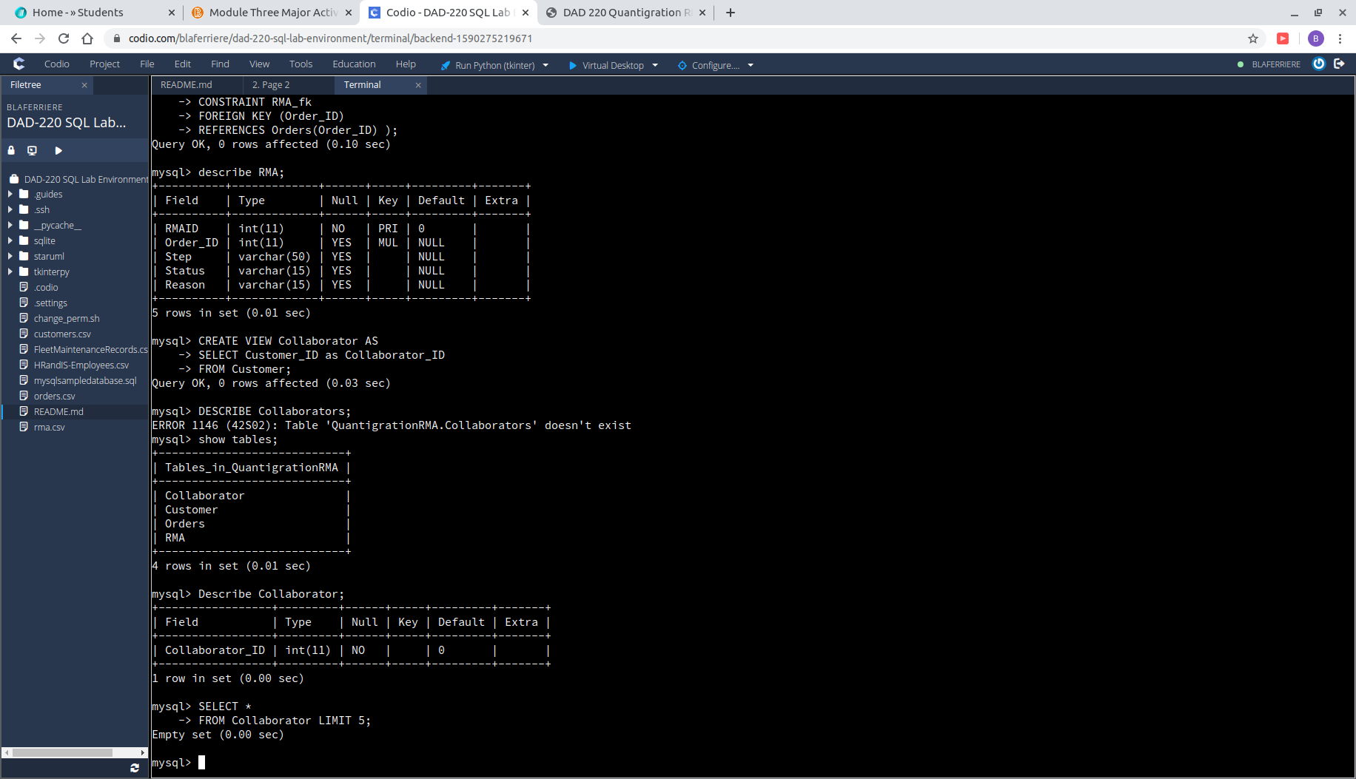
- I established a database view called “Collaborator” that is based on the “Customer” table, using the following code:

CREATE VIEW Collaborator AS
→ SELECT Customer_ID as Collaborator_ID
→ FROM Customer;

- I used “CREATE VIEW” and then assigned the name “Collaborator”. I used the word AS to begin building the pathway the view would display information from. I then selected the columns in Customer that used the word customer and reassigned them to appear as “Collaborator_ID”.

